5th Annual 5K Color Tour
~Fighting Cancer One Color at a Time~
Date: April 27, 2019
Time: 9:30am the Fun Run/Walk begins
8:30am sign-in for those that are pre-registered and sign-up for those last minute athletes
Cost: $30 for 18 & over / $25 for under 18 with early registration (by 3/29/19 and receive a free T-shirt)
$35 for 18 & over / $30 for under 18 on the day of event (after 3/29/19 first come, first serve for T-shirt)
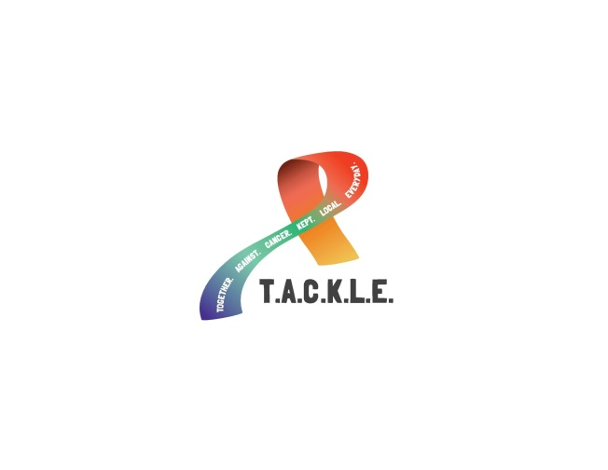
About The Race: This event is a fundraiser for the Otsego Community Foundation – TACKLE Fund. The race will begin and end under the Pavilion Downtown Gaylord. (Same course as Alpenfest 5K.) The fun run/walk will not be timed. This is an event to enjoy with your friends, family, team, or group, a time to share laughs, smiles, and stay on a path of getting healthy while helping raise funds for local individuals fighting cancer so they can focus on their treatment & recovery; versus financial burden! This is a fun run/walk where you will get showered in eco-friendly, safe color based corn starch for children and adults. At each color station you will fight cancer one color at a time! Please note: Color does wash out of MOST fabrics.
Registration: Mail in or register online. Make checks payable to Otsego Community Foundation –TACKLE Fund in Memo (entries are non-refundable). Mail registration (before 3/29/2019) and payment to:
Otsego Community Foundation – TACKLE Fund
C/O: NuEnergy Operating
PO Box 1122
Gaylord, MI 49734
https://give.otsegofoundation.org/TACKLE
Awards: This event is a fun run/walk. Awards will be given for:
Most funds raised by a team
Most funds raised by an individual
Best dressed Color Tour female over 18
Best dressed Color Tour male over 18
Best dressed Color Tour female under 18
Best dressed Color Tour male under 18
Best dressed Color Tour group
For more information check out our website: http://5kcolortour.weebly.com or contact Stacey at 989.731.0590

Name:
Address:
City: |  |  |  |  |  |  |  | State: |  | Zip:
Age: |  |  |  | Male |  |  |  | Female
(on day of event) |  |  |  |  |  | T-Shirt Size  Please Circle | Adult S Adult M Adult L Adult XL Adult XXL  Youth S Youth M Youth L
By signing below, I acknowledge that running/walking a 5k race is a potentially hazardous activity and attest that I am (or “the participant is,” if signing for a minor) medically able and properly trained to participate in this event. I agree to abide by the decisions of any event officials, and I assume all risks associated with my participation in this event, including without limitation personal property damage or loss, falls, contact with other participants, weather, and traffic or other road conditions. I hereby waive all such claims and release NuEnergy Operating, Otsego Community Foundation and their organizers, volunteers, and sponsors from any such liabilities. By submitting this entry, I acknowledge (or a parent or adult guardian for all children under 18 years) having read and agreed to the above waiver.
Signature: |  |  |  |  | Date:
(Participant or Legal Guardian if under 18)

